Initial State (Before Inserting 15)
20 (h=3)
/ \
10 (1) 40 (h=2)
/ \
30(1) 50(1)

Insertion Steps for Roll Number 15
20
/ \
10 40
\ / \
15 30 50
AFTER LEFT on NODE 10 ROTATION WILL BE:
20
/ \
15 40
/ / \
10 30 50
- Finaly the height 20 (h=3)
- The height of 15(2)
- The heught of 40 (h=2)
- The height of 10(1)
- The height of 30(1) and 50(1)
Question 2:
Output

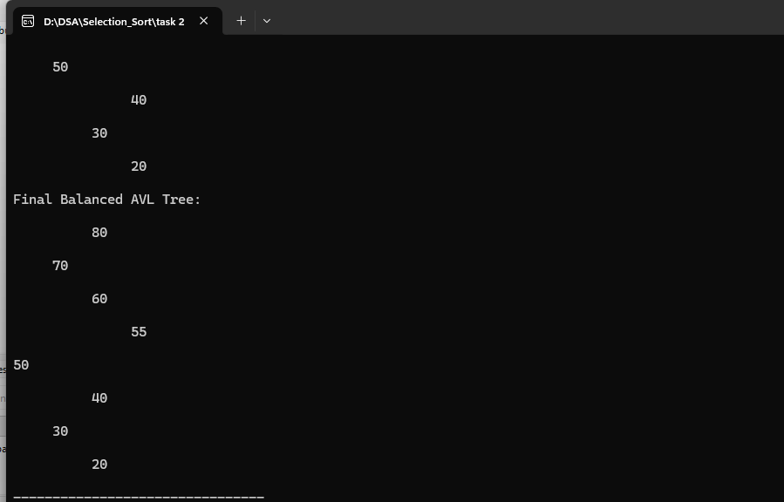
Tsk 3:
Insert the initial nodes
Insertion order: 10, 5, 15, 3, 7
10
/ \
5 15
/ \
3 7
2. Insert 12
10
/ \
5 15
/ \ /
3 7 12
3. Calculate balance factors
Formula:
BF = Height(Left)-Height(Right)
Node | Left Height | Right Height | BF
3 | 0 | 0 | 0
7 | 0 | 0 | 0
12 | 0 | 0 | 0
5 | 1 | 1 | 0
15 | 1 | 0 | +1
10 | 2 | 2 | 0
All balance factors are between -1 and +1.
4. Check tree height
Using leaf height = 1 and empty subtree height = 0:
Node | Height
3 | 1
7 | 1
12 | 1
5 | 2
15 | 2
10 | 3
Therefore:
Height=3
The tree is balanced
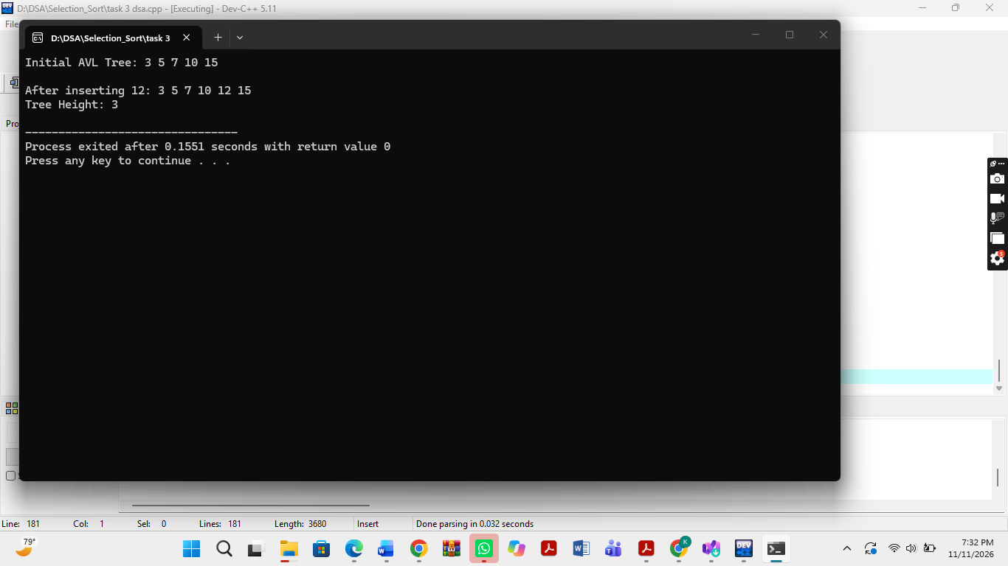
Task 4
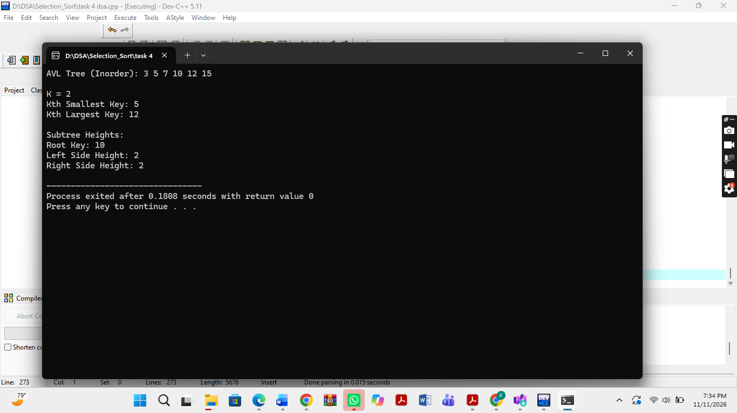
Task 5:


